**Cycling Fleece Thermal Wind Pants Winter Pants Tights Heroic bearing**

**Product Details:**

Condition: Brand New

Color:                    Black

Material:                100% Polyester

**Features:**

100% Polyester Fabric keep it warm windproof and ventilate

Reflective stripe make you safe riding at night

No cushion, used with cycling pants or shorts, also available for daily wear

1 zippered pocket on each side

Zippers on leg openings, easily to adjust

**Wash:**

Machine Wash with cool water: 30°

Do not dry clean

Do not tumble dry

Do not iron

Do not brush, Do not bleach

**Please choose your size:**

[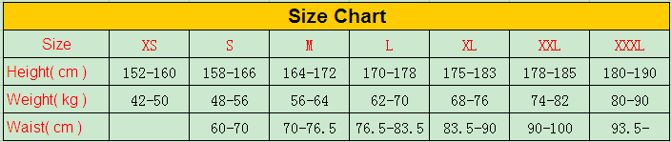](http://s572.photobucket.com/user/zljoyce/media/Man-Tights/82F159FF5C3A5BF8_zps51836d5f.png.html)

**Shipment:**

China Post Register Air Mail

Please understand that China Post Register Air Mails normally take 10-20 days to arrive. however, in some case, it need more than 1 month which may happen due to bad weather conditions, delay in local customs processing or local transportation etc. Air mails can not be tracked online in some countries.